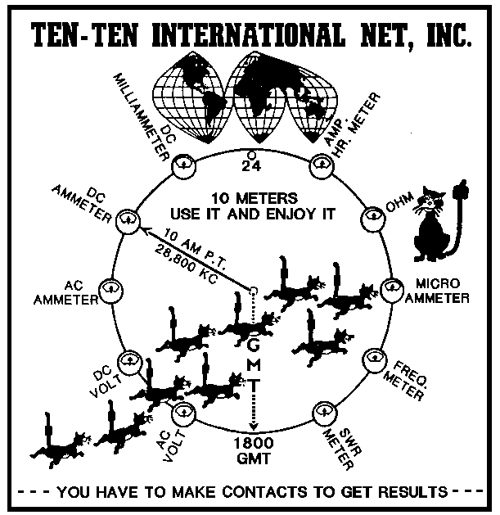
Ten-Ten International Net, Inc.
Application for Lifetime Membership

NAME: ____________________________________________ 10-10: ______________ CALL: ________________

ADDRESS: _____________________________________________________________ APT: _________________

CITY: ____________________________________________ STATE: ______________ ZIP: __________________

NOTE: ALL MEMBERSHIP DATA IS PROTECTED BY THE PRIVACY ACT OF 1974 AND WHERE APPLICABLE THE GENERAL DATA PROTECTION REGULATION. THE ONLY DATA AVAILABLE THROUGH LOOK UP SOURCES IS CONSIDER NON-PRIVATE.

Check one of the following Life Membership categories, and circle Payment plan

 | Plan ID | Plan 1 | Plan 2 |  | Plan 3
 | Payments | 1 | 1 | 2 | 1 | 2 | 3 | 4
 | US-Life | $500 | $260 | $250 | $130 | $130 | $125 | $125
 | Canada /Mexico-Life | $700 | $360 | $350 | $180 | $180 | $175 | $175
 | DX-Life | $1050 | $535 | $525 | $270 | $270 | $260 | $260
 | Electronic Delivery-Life | $360 | $190 | $180 | N/A | N/A | N/A | N/A
 | US-Senior Life | $150 | $85 | $75 | N/A | N/A | N/A | N/A
 | Canada/Mexico Senior | $350 | $185 | $175 | N/A | N/A | N/A | N/A
 | DX Senior Life | $525 | $275 | $260 | N/A | N/A | N/A | N/A
 | Electronic Delivery Senior | $120 | $70 | $60 | N/A | N/A | N/A | N/A

Plan 1 - Lifetime Membership in 10-10 International Net, Inc. Enclosed is check, money order in the amount indicated above under Plan 1.

Plan 2 - Lifetime Membership in 10-10 International Net, Inc. on a two payment plan. Enclose the amount indicated above under Plan 2, Payment 1 in the form of a check, money order or charge information. The balance to be paid within one year of this application date.

Plan 3 – NOT available for Senior Life membership or Electronic Delivery Life membership. Lifetime Membership in 10-10 International Net, Inc. on a four payment plan. Enclose the amount indicated above under Plan 3,
Payment 1 in the form of a check, money order . The second payment is due within six (6) month of this application date. The third payment is due within one year of this application date. The fourth payment is due within 18 month of this application date.

Plan 2 and Plan 3 include a record keeping fee of Ten Dollars ($10.00). The applicant understands that lifetime membership will not be granted until membership is paid in full.

Email Address for a payment reminder ______________________________

Method of payment - Check/Money Order. For Credit Cards you MUST use the online application

____________________________________________________ DATE : ____________________
APPLICANTS SIGNATURE:

Please mail completed application to:

10-10 International Net, Inc,
1349 Vernon Terrace
San Mateo CA 94402-3331
Effective Date 06/21/2019

